**Business Emergency Plan** 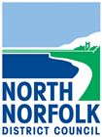



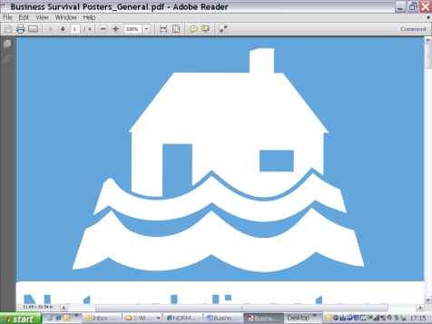







Don’t wait for an emergency to affect your business! Complete this 10 minute plan in 3 easy steps to protect your business activities. It contains the basic information you may need to help you get back up and running quickly. You can always add more information as needed.

**Step 1: What could disrupt your business?**

|  |  |  |  |
| --- | --- | --- | --- |
| **Threat** | **Unlikely** | **Likely** | **Very Likely** |
| **Flooding** (Coastal, River, Surface) |  |  |  |
| **Severe Weather** (Storms, snow or gales) |  |  |  |
| **Utility Failure** (Loss of water, electricity or gas) |  |  |  |
| **Transport Issues** (Fuel supply disruption) |  |  |  |
| **Staff illness/injury** (Pandemic flu resulting in staff shortage) |  |  |  |
| **Crime** (Theft / Vandalism) |  |  |  |
| **Loss of IT or Phones** |  |  |  |
| **Loss of Access to Premises** |  |  |  |
| **Equipment Failure** |  |  |  |
| **Failure of Key Supplier or Customer** |  |  |  |
| **Other** |  |  |  |

**Imagine one of these scenarios …..**

|  |  |
| --- | --- |
| * Electricity down for 3 to 7 days | * Schools closed for 2 weeks |
| * 40% of your staff were absent at once | * Water supply disrupted for 1 to 7 days |
| * You were a victim of theft or vandalism | * Utility suppliers severely disrupted |
| * Key roads, bridges, railway, airport or shipping severely disrupted | * Widespread loss of communication for days |
| * Your main supplier goes out of business | * Business premises flooded |

**Step 2: What could you do to protect your business?**

|  |  |  |
| --- | --- | --- |
| **Mitigation** | **In place** | **To do** |
| Fire Alarm / Safety System / Burglar Alarm |  |  |
| Premises security checks |  |  |
| Change security codes and passwords on a regular basis |  |  |
| Regular Fire Safety Check/Drill |  |  |
| Flood protection products if premises at risk of flooding |  |  |
| Staff trained to cover each other |  |  |
| Document key processes/procedures you have |  |  |
| Regular ICT backups (readily available, kept off site or cloud based) |  |  |
| Regular ICT security checks (anti virus protection) |  |  |
| Important contacts backed up and copy kept off site (including customers) |  |  |
| Links with neighbouring businesses (helping each other) |  |  |
| Talk about how you would respond with staff members |  |  |
| Alternate suppliers of key production materials or services identified |  |  |
| Keep a copy of your response plan at home |  |  |
| Other (document ideas) |  |  |

**Step 3: Your Business Emergency Plan**

Detail some of the important information for your business if there was a disruption. Keep this plan safe and share it with key staff or a family member, someone who would be able to help you if you needed to use it. Add anything else that you think would be useful in your plan.

# Your main contact details

|  |  |  |  |
| --- | --- | --- | --- |
| **Name** | **Address** | **Phone** | **Email** |
|  |  |  |  |

# Alternative premises Could you work from somewhere else if your normal premises are un-available?

|  |  |  |  |
| --- | --- | --- | --- |
| **Name** | **Address** | **Phone** | **Email** |
|  |  |  |  |

# Insurance details

|  |  |  |
| --- | --- | --- |
| **Insurance company** | **Policy number** | **Contact details** |
|  |  |  |

# People you would need to contact *(add extra rows as required)*

|  |  |  |  |
| --- | --- | --- | --- |
| **Name** | | **Role** | **Contact details** |
| **Key People** (Keyholders/Managers/Staff) | | | |
|  |  | | Tel:  Mobile:  Email:  Emergency contact: |
| **Key Suppliers** (Services/Stock/Equipment/Raw materials) | | | |
|  |  | | Tel:  Mobile:  Email: |
| **Neighbouring/Supporting Businesses** | | | |
|  |  | | Tel:  Mobile:  Email: |
| **Other Useful Contacts** | | | |
| Emergency services | 101 non emergency  999 emergencies | |  |
| Electricity – UK Power Networks (24hr faults) | 0800 316 3105  0333 323 2105 (mobiles) | | [www.ukpowernetworks.co.uk](http://www.ukpowernetworks.co.uk)  Electricity Supplier Account no: |
| Gas – National Grid (24hr emergency) | 0800 111 999 | | [www.nationalgrid.com/uk](http://www.nationalgrid.com/uk)  Gas Supplier Account no: |
| Water - Anglian Water (24hr) | 03457 145 145 | | [www.anglianwater.co.uk](http://www.anglianwater.co.uk)  Water Supplier Account no: |
| Telephone provider |  | |  |
| NNDC | 01263 513811 | | <http://www.northnorfolk.org/> |
| Others |  | |  |

# Action Card

* Call 999 if people or property are in danger
* Assess the impact on your business and how long it will last
* Contact your insurance company (take lots of pictures as evidence of any loss or damage)
* Contact staff, suppliers and customers to let them know what has happened
* Identify what business activities can continue and which may need to be put on hold
* Speak to neighbouring businesses to see if they can help
* Contact your local council to see if they can help in any way
* Stay in contact with key people, keep them informed